Add a Daily TQA Note with Your Initials

**Purpose:** It is easier to troubleshoot unexpected TQA results when we know who ran the daily morning tests. Since all therapists use the same TQA account, there is no way for us to know who ran the tests unless that individual records that information somewhere. An easy way to do this is to add a **Note** in the TQA software after you finish running the tests.

1. After you finish running all daily TQA tests, log into TQA.
   1. Click the Internet Explorer icon at the bottom left of the Tomo computer. You should see the login page for TQA.
   2. Log in with username *therapist* and password *therapist1_* (same credentials as Tomo except that this password has an underscore).
2. Add a note with your initials. Do this regardless of test results. Physics checks TQA results every morning, so you do not need to do this. All we need are your initials.
   1. Click the **Notes** tab and **Add a note**.

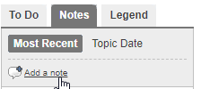

* 1. Add your initials as the **Subject**. You may leave the **Details** blank.

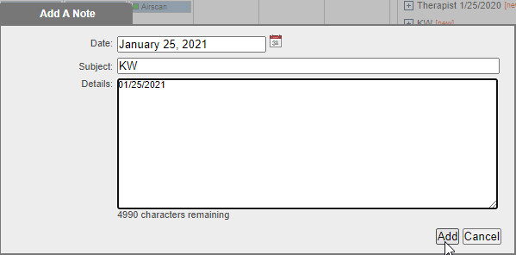

1. Close out of TQA software.